**SMART DIGITAL ASSISTANT**

Akksaya Rajasri G P1, Durga devi S2, Gracelin S3, Dr. Pasumponpandian P4

1, 2, 3UG Scholar/CSE, KGiSL Institute of Technology, Coimbatore, India

4Head of Department, Department of Computer Science, KGiSL Institute of Technology,

Coimbatore, India

[Pasumponpandian@kgkite.ac.in](mailto:Pasumponpandian@kgkite.ac.in)

[Akksayarajasri.g.p2015@kgkite.ac.in](mailto:Akksayarajasri.g.p2015@kgkite.ac.in)

[Durgadevi.s2015@kgkite.ac.in](mailto:Durgadevi.s2015@kgkite.ac.in)

<Gracelin.s2015@kgkite.ac.in>

# *Abstract- This paper presents a different idea about the custom skills of Amazon Alexa. Amazon alexa is a virtual personal assistant, also known as an AI assistant or digital assistant, an application program that understands voice commands and completes user commands. There are so many skills available and ideas on such custom skills are being discussed here. Alexa skills are nothing but the apps that give Alexa even more capabilities, letting even websites talk to more devices. We discuss fuel monitoring service for users of vehicles using alexa in this paper. Using alexa with lambda function, this service can implement this service and describe how it works with alexa.*

# *Keywords-Amazon alexa, Lambda function, echo*

**I. INTRODUCTION**

Alexa is the cloud-based service Amazon provides on various Amazon devices. You can control in natural conversational language with the help of Alexa, and Alexa fulfills that commands using the Amazon skill kit and lambda function. The Alexa skill kit consists of the APIs, tools and documentation to create these new skills, powered by your own services running as functions of Lambda. We can manage computing operations such as memory balance, CPU, network, and other resources by using the lambda function. When the vehicle user asks alexa to predict the fuel level, the alexa will redirect the request to the lambda function and collect the required information from the S3 and supply the fuel.

**Problem Definition**

The existing system needs a human to look into the fuel level readings and know the results, which is time consuming, and in the busy routine works it is also an extra task for the user. Our proposed system reduces them by automating the entire process using a voice user interface (Amazon Alexa echo dot) that will be much faster than the existing system that also reduces time and man power consumption.

**Objective of the Project**

The aws lambda is a service that gathers data from the database (s3). Lambda returns the accurately stored quantity or level of fuel to the user. The alexa makes it possible to improve the fuel monitoring system by reporting the results to the user whenever we request using voice recognition techniques.

**Existing System**

The existing system needs a human to look into the readings of fuel level and know the results, which is time consuming and is also an extra task for the user in the busy routine works.

**Drawbacks of Existing System**

The main disadvantages for the existing system are:

• Take more time to process.

• The data lacks security and accuracy.

• Manual processing is required in large quantities.

• Potential for manual processing and calculation errors.

**LITERATURE SURVEY**

In[ 1] author presented the idea of using the open source code made available by Amazon on GitHub to build Amazon Alexa on Raspberry Pi. Author also highlighted the need for Alexa to accurately respond to high-quality audio input microphones. In[ 2] author presented as an additional feature a model approach for developing personal assistant with remote access. Details on web task and end-user interaction (EUI) were discussed in thesis[ 3] with IFTTT high and low complexity task breakdown and comparison with other interfaces. In[4]Voice control of home appliances with Android Voice command is used for home appliances ON / OFF Need additional HW for electrical appliances ON / OFF.

**PROPOSED SYSTEM**

Our proposed system reduces them by automating the whole complete process using a voice user interface (Amazon alexa echo dot) which will be much faster than the Existing system, also reduces the time and man power consumption. In our system user ask tank capacity through voice user interface (mic). User request sends to backend by connected endpoint, it will fetch the data from database and triggred to lambda. Lambda return information to the user.

**Advantages**

The major advantages for proposed system is as follows

* Minimal man power consumption.
* Minimal time consumption
* Consistency as the software bot could run continuously.

# Section-I UNDERSTANDING BASIC CONCEPT AND USED SERVICES

**Alexa Voice Service:**

The Alexa Voice Service (AVS) is Amazon's suite of services for home and other environments built around its voice - controlled AI assistant. Alexa enables voice interaction in the environment and online with different systems.

# Simple Storage Service:

# Amazon Simple Storage Service is a web - based, scalable, high - speed cloud storage service designed for online backup and archiving of Amazon Web Services data and applications.

# Lambda function:

Using AWS Lambda to process AWS events, An event source is an AWS service or application created by developers that generates events that trigger a running function of AWS Lambda. For example, Lambda can pull records from a stream of Amazon Kinesis or a queue of Amazon SQS and execute a function of Lambda for each message.

# AWS Polly:

# Amazon Polly is a service that transforms text into lifelong speech, enabling you to create applications that speak and create entirely new categories of speech-enabled products. Amazon Polly is a Text-to-Speech service that synthesizes speech that sounds like a human voice using advanced deep learning technologies.

# AWS Lex:

Amazon Lex is a service that uses voice and text to create conversational interfaces in any application. Using these technologies, Amazon Lex allows you to define completely new product categories made possible through conversational interfaces.

**Section-II DIAGRAM OF FLOW OF MESSAGE FROM ALEXA TO USER**

The user asks alexa to use the vehicle name to read out tank capacity whenever necessary. Alexa allows the device to record and forward that voice to alexa APIs. Lambda function includes functions that collect user-sent information such as vehicle name. It works with simple storage service (s3) to match vehicle name with record. The alexa collects information from the console when the vehicle name matches the lambda

function and reads the tank capacity to the user.

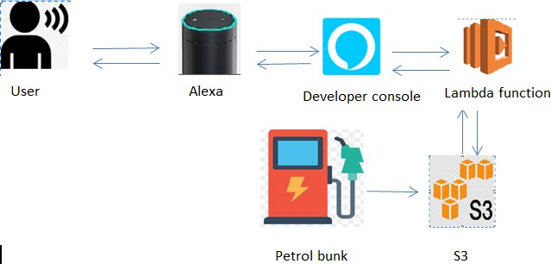

Fig.1. Tank Capacity Monitoring System using alexa and lambda

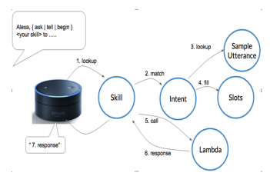

Fig.2. ASK Workflow

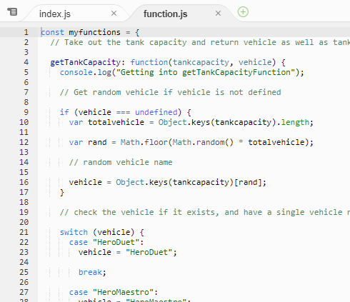

Fig.3. Lambda function

**Section III: CONCLUSION AND FUTURE WORK**

We believe our idea will help users to know different vehicles' tank capabilities. And when asked, alexa will report it to the user. In future skills, we will allow alexa to monitor and report the fuel level in the vehicles to users, so that users can be alarmed about the fuel level.

**REFERENCES**

[1] W. Wayt Gibbs, “How to build your own Amazon Echo”, IEEE spectrum, April 2017.

[2] Rasika Anerao, Utkarsh Mehta, Sharangdhar Vaze, G. Hrishikesh, “Personal Assistant to Facilitate User Task Automation”, IJCTT, vol.15, number 4, Sept. 2014.

[3] Yitaek Hwang, “Alexa skills Kit Tutorial- Building Custom Skills with Alexa”, Article in IOT for all, February 2017.

[4] NorhazahbtAripin, M. B. Othman, "Voice control of home appliances using Android", Electrical Power, Electronics, Communications, Controls, and Informatics Seminar (EECCIS), 2014.

[5] ArunGopi, Shobana Devi P, Sajini T, Bhadran V K, "Implementation of Malayalam Text to Speech Using Concatenative Based TTS for Android Platform", International Conference on Control Communication and Computing (ICCC), 2013.

[6] ShraddhaUddhavkhadilkar, NarendraWagdarikar, "Android phone controlled Voice Gesture and Touch screen operated Smart Wheelchair", International Conference on Pervasive Computing (ICPC), 2015.

[7] Maya Rida, Michel Nahas, MiladGhantous, "iSee: An Android Application for the Assistance of the Visually Impaired", Springer International Publication, 2014